Abstract Template

Ivanov A.B.¹, Smith V.I.²
¹Lobachevsky State University of Nizhni Novgorod, Nizhni Novgorod, Russia
²University of Rostock, Germany
E-mail: ivanov@mail.ru

Abstract of not more than 1 page should be submitted with file name section number_SurnameNP.doc(x) until December 1st, 2020 (for example, 5_SmithVI.doc). Font size – 14, Times New Roman, single space – for Microsoft Word; all margins 2 cm.
The title: bold. Then single space. Then Authors according to the sample Surname N.P. (surname of the presenting author should be underlined). Then Organization, City, Country (Italic). Then single space. Then the text of the abstract (every paragraph 1 cm).
Figures (fig. 1) and tables (table 1) should be done according to the template. Font size in figure captions, table headlines and tables – 12.

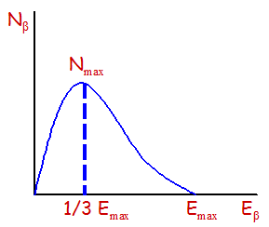
Fig. 1. Spectrum of β-radiation.

Table 1. Results of measurement.
Method of extraction | Average extraction level, %
Acid-alkaline | 98-107
Solid state | 50

References (if any) should be written after the text of abstract without spaces, as in the example below [1], and necessarily cited in the text of the abstract.
Acknowledgements should be given in the text without additional single space, without the use of italics according to the example. This work was supported by the Following Foundation (Project No._).
References
[1] Velmuzhov A.P., Knyazev A. // Russian Journal of Inorganic Chemistry. 2014.
V. 58. P. 982-987.

